Project Design Phase

Problem–Solution Fit Template

Date | 06 November 2025
Team ID | F529277D47452DB9E7447BD087E08E5E
Project name | Medical inventory management
Maximum Marks | 4 Marks

1. Problem Statement
- Hospitals and clinics struggle to efficiently manage medical inventory.
- Frequent issues include:
  - Overstocking or stockouts of critical supplies.
  - Expired medicines or unused equipment.
  - Lack of real-time visibility of inventory levels.
  - Manual record-keeping leading to errors and delays.
  - Poor coordination between departments and suppliers.

2. Target Users / Stakeholders
- Hospital administrators
- Pharmacists and store managers
- Nurses and medical staff
- Suppliers / vendors
- Biomedical engineers (equipment maintenance)

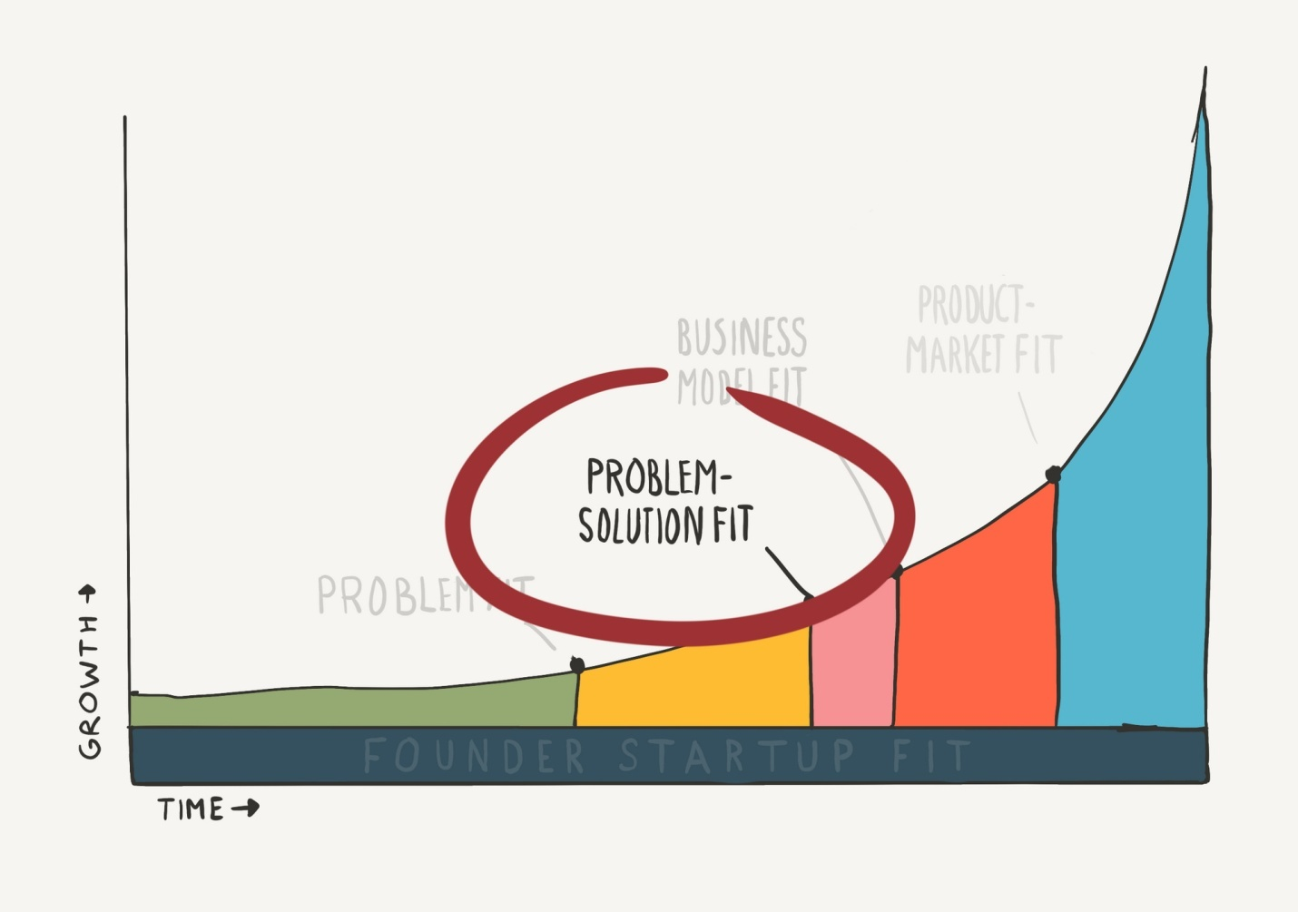

3. User Needs / Pain Points
User Type | Pain Points / Needs
Pharmacist | Need real-time alerts for low or expiring stock
Nurse | Need quick access to available items during emergencies
Administrator | Need accurate usage and cost reports
Supplier | Need timely restocking requests
Maintenance Team | Need tracking of medical devices and their maintenance schedules

4. Proposed Solution
Develop a Medical Inventory Management System that:
- Tracks real-time stock levels of medicines, consumables, and equipment.
- Sends automatic alerts for expiry and low-stock items.
- Generates detailed reports on inventory usage and trends.
- Integrates with supplier systems for auto-replenishment.
- Provides secure, role-based access (admin, pharmacist, nurse).
- Uses barcode or QR scanning for fast item tracking.

5. Key Features
✅ Real-time inventory dashboard
✅ Expiry date tracking and alerts
✅ Automated reorder system
✅ Purchase order management
✅ Supplier and vendor management
✅ Usage reports and analytics
✅ Role-based access control
✅ Cloud backup and data security

6. Expected Benefits
- Reduces wastage of medical supplies.
- Ensures timely availability of essential items.
- Minimizes manual errors and paperwork.
- Saves time for healthcare staff.
- Improves patient care through efficient supply management.
- Enhances financial control and accountability.

7. Success Metrics
Metric | Goal / Indicator of Fit
Reduction in expired stock | ↓ 80% within 6 months
Stock-out incidents | ↓ 90% compared to manual tracking
Time saved in stock management | ↓ 50%
User satisfaction | > 90% positive feedback
Cost savings | ↓ 20–30% in procurement waste

